
Tool 4:
Stakeholder mapping and planning tools
Contains stakeholder mapping, partner readiness assessment, role mapping, and trust mapping tools
November 2026
Sponsored by:

Stakeholder mapping tool
This tool helps you identify, prioritize, and plan engagement with the stakeholders who can shape the success of a community health intervention. Use it to clarify who needs to be involved, how much influence and interest they have, and what engagement strategy is most appropriate for each group.
Step 1: Brainstorm a list of all potential stakeholders, including:
- Traditional health partners:
  - Hospitals, health systems, and clinics
  - County health departments
  - Behavioral health providers
  - Federally Qualified Health Centers (FQHCs)
- Community-based organizations:
  - Food pantries, shelters, and mutual aid groups
  - Senior centers
  - Faith-based organizations
- Public sector and government entities:
  - Local elected officials
  - Tribal councils
  - School districts
  - EMS, law enforcement
- Businesses and employers:
  - Major local employers
  - Farm bureaus and agricultural co-ops
- Residents with lived experience:
  - Community champions
  - Caregivers
  - Youth and elders
- Others:
  - Researchers
  - Philanthropic funders
  - Policy advocates

Step 2: Stakeholder categorization table
Write the name of each stakeholder in the table below and evaluate it on two criteria:
- Level of influence (high, medium, or low): How much power do they have to affect decisions, policies, funding, or community norms?
- Level of interest (high, medium, or low): How much do they care about the health topic or convening outcomes?

Stakeholder categorization
Stakeholder name | Sector | Influence (high, medium, or low) | Interest (high, medium, or low) | Notes/considerations
Example: County health department | Public health | High | High | Key policy and funding authority

Step 3: Stakeholder influence-interest matrix
Plot stakeholders on the matrix below to decide your engagement strategies.
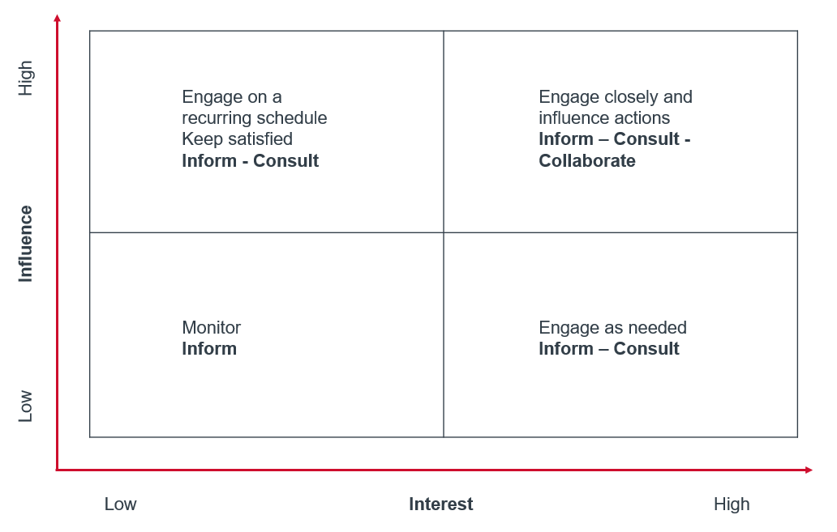
Interpretation:
- Key players: High influence, High interest — Co-design, co-lead, partner closely
- Keep satisfied: High influence, Low interest — Keep informed, consult strategically
- Keep informed: Low influence, High interest — Regular updates, listening sessions
- Monitor: Low influence, Low interest — Inform occasionally, minimal effort
Step 4: Stakeholder profile sheets
For each key player identified in step 3, gather additional details.
- Contact information
- Current programs or initiatives
- Past engagement experience
- Potential concerns or barriers
- Alignment with convening objectives
- Level of involvement desired
- Preferred communication methods
- What they bring to the table:
  - Expertise
  - Community trust
  - Resources

Step 5: Engagement strategy planner
Determine how you’ll engage each stakeholder group.

Engagement strategy planner
Stakeholder group | Engagement tactic | Frequency | Responsible person
Key players | Codesign workshops | Monthly | Convening lead
Keep satisfied | Quarterly briefings | Quarterly | Policy liaison
Keep informed | Newsletters, listening sessions | Once every other month | Community engagement manager
Monitor | Annual updates | Annually | Administrative support

Step 6: Periodic reevaluation
Revisit the table and matrix in steps 2 and 3 periodically to:
- Refresh contacts
- Add new partners
- Reassess influence and interest as priorities evolve

Partner readiness assessment
This tool helps you assess whether your organization is prepared to engage effectively in a community-based convening effort with cross-sector partners to advance public health priorities. Use it to identify strengths, gaps, and supports needed to ensure productive collaboration.
Organizational readiness
☐ Leadership support: Leaders understand and support participation in the convening process.
☐ Alignment with mission: The effort aligns with our organization’s mission, values, and strategic goals.
☐ Dedicated staff capacity: We have staff time allocated to participate and follow through on commitments.
☐ Decision-making authority: Representatives have authority to speak on behalf of our organization or a clear process to escalate decisions.
Resource commitment
☐ Financial resources: We can contribute (or seek) resources if needed (in-kind, funding, or meeting space).
☐ Data sharing willingness: We are willing to share relevant data to inform community priorities.
☐ Technical expertise: We can offer expertise (subject matter, facilitation, evaluation, and communications).
Collaboration experience
☐ Cross-sector collaboration history: Our organization has worked in partnerships with diverse sectors before.
☐ Community engagement skills: Staff have experience engaging with community members in a culturally responsive way.
☐ Conflict resolution processes: We have a process to navigate disagreements constructively.
Community trust and relationships
☐ Existing community relationships: Our organization has relationships with priority populations or groups.
☐ Commitment to equity: We are committed to advancing equity and sharing power with community stakeholders.
☐ Transparency and accountability: We are prepared to communicate openly and be accountable to partners and community members.

Logistics and planning
☐ Availability for convening activities: We can commit to regular meetings, preparation time, and follow-up activities.
☐ Clear communication channels: We can designate consistent points of contact.
☐ Technology readiness: We have access to technology for virtual meetings and shared documents.
Key considerations
Use these guiding questions to prompt internal reflection:
- Why are we participating? What does success look like for us?
- Who will represent us? Do they have the skills and authority needed?
- What can we offer (expertise, resources, relationships)?
- What do we need (training, data, funding, translation services)?
- How will we communicate internally and externally? How will we keep leaders and staff informed?
- What are our boundaries? Do we have any limitations on participation, commitments, or resource sharing?

Role mapping tool
Use this tool to define each partner’s role in advancing a shared community health initiative. It will help teams assign responsibilities, surface gaps or overlaps, and document next steps for more coordinated collaboration.

Purpose
To help cross-sector partners:
- Clarify individual and organizational roles.
- Avoid duplication and confusion.
- Make the most of each partner’s strengths.
- Identify gaps in leadership or capacity early.

Key principles
- Be transparent about expectations.
- Recognize different types of contributions (leadership, staffing, funding, communications, etc.).
- Revisit and update as the project evolves.

Facilitation tips
- Have partners fill out the worksheet together while convening.
- Use sticky notes on a wall chart so people can move roles around.
- Revisit the role map created with this tool quarterly or as the project evolves.

Instructions
Write a short (2–3 sentence) description of the project or initiative you are mapping roles for. Example: “Expanding access to mental health services for youth and families across the county, with a focus on schools and telehealth.”

Step 1: Key activities or functions
List the main activities or workstreams that will be part of the project:
- Community engagement
- Data collection and analysis
- Policy advocacy
- Program implementation
- Communications and outreach
- Evaluation and reporting
- Funding/resource development

Step 2: Role definitions
Define what each role means in your context. You can adapt this framework or create your own.

Role type | Description
Example: Lead | Primary accountability and decision-making authority for this area.
Example: Contributor | Provides support, expertise, or resources to this area.
Example: Consulted | Informed and asked for input but not responsible for doing the work.
Example: Informed | Kept updated about progress and outcomes.

Step 3: Role mapping table
Fill in who will serve in each role for each function.

Activity/function | Lead organization(s) | Contributors | Consulted | Informed
Example: Community engagement | ABC nonprofit | Health department, youth coalition | Schools | Funders, city council
Example: Data collection and analysis | County health department | University public health program | Nonprofits | All partners

Step 4: Gap identification
Review the table and discuss:
- Are any functions missing a lead organization?
- Are there too many lead organizations?
- Where is capacity limited?
- Are there perspectives missing from the “consulted” or “informed” fields?

Identified gap or overlap | Potential action or solution
Example: No clear lead for evaluation | University partner to confirm capacity
Example: Overlap in communications responsibilities | Develop shared messaging protocol
Example: Lack of youth representation | Invite youth advisory council to be consulted

Step 5: Document decisions and next steps

Action item | Responsible party | Deadline
Example: Finalize role assignments | Convening lead | July 15
Example: Draft memorandum of understanding (MOU) clarifying expectations | Project manager | July 30
Example: Share updated role map with all partners | Communications lead | August 5

Trust mapping tool
This tool guides pre-convening reflection and planning to help providers surface, understand, and address trust dynamics in community and cross-sector partnerships before launching new heath interventions.

Step 1. Stakeholder trust landscape table. Who are we working with?

Identify all relevant stakeholders, assess the current state of trust with each, and document the root causes of either trust or mistrust. This is the foundation of your trust mapping process.

Instructions
- Begin with your existing Stakeholder influence-interest matrix (page 3) to identify and categorize key players.
- From this, transfer high- and medium-priority stakeholders into the trust mapping tool below for deeper analysis. These will typically be the key players and keep satisfied stakeholder groups
- Fill in columns for organization type, existing relationship, and if known, an initial read on community perception of trust (low, medium, or high).
- In the “System trust history” column, use the Trust-related word bank (see appendix, page 16) to flag observations or gaps that require deeper analysis or adjustment. There, notes will guide targeted follow-up in later sections

Stakeholder trust landscape
Stakeholder group or name |  | Type (CBO, FHQC, etc.) | Existing relationship | Community perception of trust | System trust history | Trust-building priority level
 |  |  | Note whether stakeholder has prior engagement (e.g., planning tables, informal partnerships). | Capture how community members view the stakeholder, not just the system.  Use this column as a hypothesis space: Unknown, anecdotally trusted, mixed, or to validate | Note whether the stakeholder has been engaged meaningfully in the past or excluded/  marginalized | Low priority if: Existing partner with sustained trust  Medium if: new or emerging partner  High priority if: Influential and trust is fractured or unknown
Example 1 |  | County hospital | Partnered in past grant | Mixed — trusted by peers, not by patients | Previously excluded community health system from planning | High — bridge patient trust

Step 2. Trust dimensions diagnostic

Understand how trust shows up across relationships (institutional, relational, cultural, etc.).

Instructions
- Use the Role mapping tool (starting on page 7 of this document) to assess each stakeholder’s concern, historical friction points, or communication preferences.
- Rate each trust dimension using team knowledge, direct feedback, or known community dynamics. You can use a 1-3 system (with 1 indicating low trust, 2 indicating medium trust, and 3 indicating high trust).

This diagnostic informs tailored engagement strategies in step 5 of this tool on page 14.

Trust diagnostic table
Stakeholder group or name | Institutional trust | Relational trust | Cultural or identity safety | Transparency history | Respect for autonomy | Notes

Step 3. Historical and relational context

Document events, partnerships, or system interactions that influence current trust levels.

Instructions
- Use Leverage CHNAs, local history, or prior partner feedback.
- Use this section to flag prior broken commitments, wins, or incidents that shape stakeholder sentiment today.

Trust timeline table
Event or experience | Year(s) | Impact on trust | Stakeholder affected | Lessons

Step 4. Trust risk indicators

Identify signs that trust may be weak, fraying, or at risk.

Instructions
- Review this checklist prior to reaching out to partners.
- If more than two risks are identified, visit the Engagement strategy planner (see step 5 on page 4 of the Stakeholder mapping tool).

Trust risk indicator checklist

Voice and representation
Indicator | What it might mean
☐ Overreliance on institutional voices vs.  community-based voices | The conversation is dominated by hospitals, funders, or agencies — without grassroots, lived-experiences, or culturally embedded partners.
☐ Lack of community representation in decision-making | Even if present in listening sessions, community voices aren’t reflected in final decisions or governance structures.
☐ Visible power imbalances in convenings | Senior leaders or institutional representatives dominate space, leaving little room for grassroots or underrepresented voices.

Follow-through and accountability
Indicator | What it might mean
☐ Promises made in past engagements not kept | Past commitments were not fulfilled, reducing credibility (e.g., “This will shape funding”).
☐ Repeated engagement without systems changes | Communities are repeatedly asked for feedback on the same issues without seeing material change.
☐ Engagement seen as extractive or one-sided | Community members feel that input is taken but not reciprocated, especially when feedback is collected without updates or co-ownership.

Communication and transparency
Indicator | What it might mean
☐ Silence, skepticism, or hesitancy during outreach | Lack of RSVPs, vague responses, or guarded feedback may indicate low trust or fear of being misrepresented.
☐ Perception that engagement is performative | Communities feel engagement is being done “for show,” compliance, or public relations rather than genuine partnership.
☐ Concerns about data use or confidentiality | Stakeholders worry their responses will be used against them or taken out of context.

Resource and equity
Indicator | What it might mean
☐ Mistrust related to funding or resource allocation | Communities or partners suspect inequitable distribution of resources or exclusion from funding decisions.

Communication and transparency
Indicator | What it might mean
☐ Staff turnover affecting continuity | Changes in outreach staff or partner liaisons disrupt relationships and create confusion or instability.
☐ Community fatigue or survey burnout | Stakeholders have participated in too many engagement efforts without seeing results — leading to disengagement or skepticism.
☐ Cultural or language mismatches | Language access or cultural relevance is missing, making participants feel alienated or misunderstood.

Step 5. Engagement strategies to build and strengthen trust

Select the right engagement strategies to strengthen trust based on previous diagnostics.

Instructions
- Pull from or adapt your Engagement strategy planner (see step 5 on page 4 of the Stakeholder mapping tool).
- Choose specific tactics aligned with each trust dimension gap.
- Use this to plan who should engage, how, and when for each stakeholder group.

Engagement strategies
Strategy | Applicable when… | Action | Assigned to | Status
Co-create engagement questions | Community has felt excluded from agenda setting | Example: Invite community reps to edit or prioritize listening session questions |  | Example: Started, in progress, or complete
Use trusted cultural brokers or connectors | There’s a history of cultural mismatch or language gaps | Example: Partner with promotoras, elders, or faith leaders to co-facilitate sessions
Publicly close the loop | Prior feedback was not acknowledged or acted on | Example: Share a post-engagement summary outlining decisions, actions, and next steps
Offer multiple formats for input | Some participants are less comfortable with group discussions or formal settings | Example: Include options like anonymous comment boxes, one-on-one conversations, or text messaging
Clarify how data will be used and protected | Communities have concerns about confidentiality or misuse | Example: Start sessions with a data use statement and consent explanation in plain language
Invest time in  pre-session trust building | Relationship is new or sensitive | Example: Conduct informal “get-to-know-you" visits, attend community event, or host  pre-convening coffee chat
Ensure visible representation in decisions | Community input hasn’t translated into power or visibility | Example: Invite community members to  co-present findings or sit on review committees
Use community-friendly materials | Language or format has been a barrier in past outreach | Example: Translate materials, avoid jargon, and  co-design visuals with the audience in mind
Adapt pace and expectations | There’s a history of engagement fatigue or slow systems change | Example: Set shared timelines and clarify what’s feasible in the short and long term
Acknowledge historical context openly | Past harm, broken trust, or exclusion has occurred | Example: Begin with a statement that names historical dynamics and commits to doing better
Prioritize small wins and shared actions | Stakeholders are skeptical about follow-through | Example: Identify one near-term action that can be acted on collaboratively within 30-60 days

Appendix

Trust-related observations and gaps word bank
Past relationship dynamics | Engagement style concerns | Trust level signals | Equity and inclusion flags | Readiness and role clarity
History of broken promises | Prefers informal outreach | Low institutional trust but strong personal relationships | Historically excluded from regional planning efforts | Seeks clarity on expectation before committing
Engaged only during crisis or emergency | Responds best to peer-based communication | Relational trust, but limited decision-making influence | Identifies as underrepresented voice | New to this type of collaboration
Expressed disappointment in past funding or follow-up | Hesitant with system branded outreach | Seen as neutral convener by others | Newer organization still building recognition | Open to collaboration but resource constrained
Engagement stopped after pilot | Feels over-surveyed or data fatigued | Trusted by community but skeptical of system actors | Requests shared leadership or co-facilitation roles | Asks: “What’s different this time?”
Previous partnership dissolved | Avoids public meetings, needs  1:1 relationship | Trust dependent on one individual’s involvement | Needs translation, American Sign Language, or disability accommodations | Inquired about sustainability or long-term outcomes
Strong rapport with legacy staff only | Has voiced concerns about cultural or linguistic mismatch | Skeptical of power dynamics at the table
Past involvement was extractive | Requires consistent point of contact


- Promotoras are trusted community health workers in Hispanic/Latino communities who serve as a bridge between individuals, communities, and the healthcare system.

